Multiple choice section – choose the correct answer

Question 1 [6.1]

For the triangle shown,  is equivalent to:

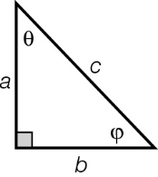

A  B  C  D 

Question 2 [6.1]

The angle 22.07° +  is closest to:

A 34.03 B 35.04° C 35.36° D 34.65°

Question 3 [6.2]

The value of *y* is:

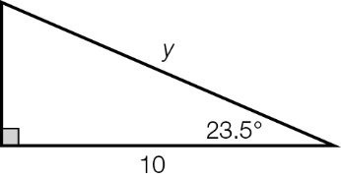

A 10.9 B 11.2 C 15.2 D 11.3

Question 4 [6.2]

A mine shaft 100 m long is dug at an angle of 20°32′ to the vertical. In metres, what is vertical depth of the mine shaft?

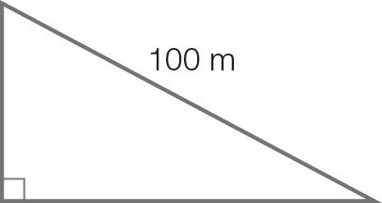

A 93.65 B 37.45 C 83.68 D 35.08

Question 5 [6.3]

The value of θ in degrees and minutes is:

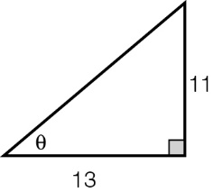

A 42°26′ B 43°18′ C 40°14′ D 39°56′

Question 6 [6.4]

The angle of elevation of the top of a pole from a point on the ground 30 m away is 26°. The height of the pole in metres is:

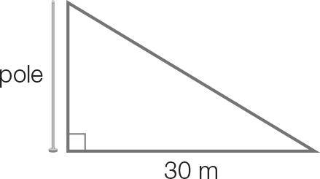

A 13.15 B 26.96 C 14.63 D 15.05

Question 7 [6.5]

John leaves home and drives 25 km on a bearing S35° E . He then drives due north until he is due east of home. How far in km from the house is he?

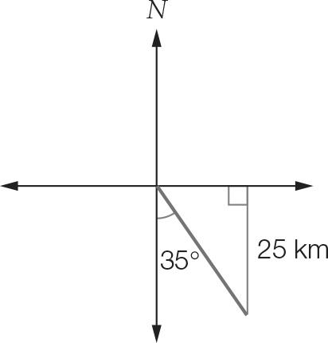

A 63.2 km B 14.3 km C 126.4 km D 43.9 km

Question 8 [6.5]

The angle θ is measured clockwise from north. If , then the compass bearing is:

A N30°E B N60°E C 060°T D 030°T

Multiple-choice total marks: ___ / 8

Short answer section

Question 9 2 marks [6.2]

Calculate the values of *x* and *y*, correct to 2 decimal places.

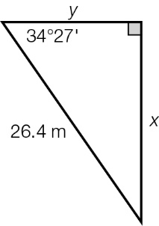

Question 10 2 marks [6.3]

Two kites are flown as shown. Find the angles α and θ that the strings make with the ground, expressed in degrees and minutes.

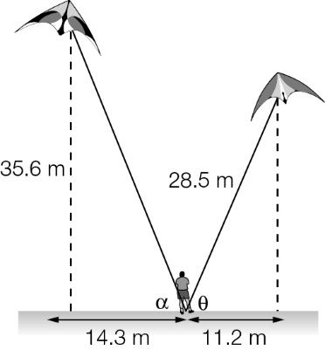

Question 11 3 marks [6.4]

Omar climbed a tree to a height of 10.2 m above the ground. His dog runs away from the base of the tree at 6 m/s. Find the angle of depression in degrees and minutes from Omar to his dog after 3 seconds.

Question 12 3 marks [6.4]

Sabina is standing 5.45 m in front of a flagpole 6.22 m high. The vertical distance from the top of her head to the top of the flagpole is 5.70 m and her eyes are 13 cm below the top of her head. What angle of elevation must Sabina look up at to see the top of the flagpole? Round your answer to the nearest degree.

Question 13 4 marks [6.6]

An ant walks from point A to point B and then to point C.

(a) What is the true bearing of point B from point A, correct to 2 decimal places?

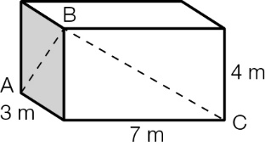

(b) How far did the ant walk to get from B to C, correct to 2 decimal places?

Short answer total marks: ___ / 14

Extended response section

Question 14 6 marks [6.6]

Lights attached to two cables are strung through two trees. The first cable makes an angle of 37.1° from the ground to the first tree. The second cable makes an angle of 64° from first tree to the second tree, as shown in the diagram. (There is no cable along the ground.) Find the length of the cable to the nearest centimetre.

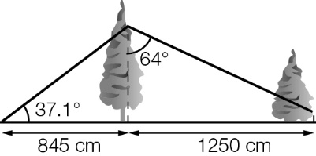

Question 15 5 marks [6.5]

An aircraft leaves the airport and flies 60 km on a bearing of . The aircraft then turns clockwise 90° and flies for a further 32 km before flying directly back to the airport.

(a) What was the total length of the flight?

(b) What is the bearing from the airport to the end of the second part of the flight? Give your answer to 2 decimal places.

Extended answer total marks: ___ / 11

TOTAL test marks: ___ / 33